Minutes

 | KANSAS WATER AUTHORITY
January 29, 2020 | Topeka, Kansas | Regular Meeting

Call to Order: Chair Connie Owen called the January 29, 2020 Kansas Water Authority meeting to order at 8:35 a.m. at the Cyrus Hotel Ballroom in Topeka, KS

VOTING Members
Present: Connie Owen; chair; Mike Armstrong, John Bailey; Mark Fischer; Greg Graff; Randy Hayzlett; Jeremiah Hobbs; Alan King; Chris Ladwig; Carolyn McGinn; Ted Nighswonger; Dennis Schwartz; David Stroberg

Ex-Officio Members
Present: Patty Clark; Susan Duffy; Earl Lewis; Chris Beightel; Rolfe Mandel; Dan Devlin; Brad Loveless; Rob Reschke; Sara Baer; Eric Glave; Mike Beam;

Voting Members
Absent: ALL PRESENT

EX-OFFICIO Members All Present
Absent:

Approval of Minutes:
Motion No. 01-20-01 It was moved by Mike Armstrong and seconded by Dennis Schwartz the December 19, 2019 Minutes for the Regular Meeting of the Kansas Water Authority be approved as presented. Motion carried with no dissenting votes. Information found in meeting materials.

KWA/PWS Committee:

Dennis Schwartz gave an update.

KWA/PWS Committee:
Comprehensive Development Plan

Nathan Westrup gave an update.

Legislative Update:
Earl Lewis and Matt Unruh presented

Performance Based Budget Task Force:

Motion No. 01-20-02 It was moved by Mike Armstrong and seconded by John Bailey to the Kansas Water Plan Budget Guidelines.
Motion carried with no dissenting votes. Information found on page 4 of meeting materials.

Research Coordination Work Group:

Dan Devlin gave an update

Research Coordination Work Group:
HAB Research Update

Elizabeth Smith with KDHE presented on the Kansas HAB Response Program Overview.
Ted Harris with KBS presented on Are HABs Increasing.
Information found in KWA meeting presentations.

Federal Updates:

Cara Hendricks and Matt Unruh gave and update.

Federal Update:

Motion No. 01-20-03 It was moved by Mike Armstrong and seconded by Randy Hayzlett to propose sending a letter to the Council on Environmental Quality (CEQ) to agree with and support a 60 day extension of the comment period on proposed regulations to the National Environmental Policy Act (NEPA).
Motion carried with no dissenting votes. Information found on page 10 of meeting materials.

Arbuckle Study Update:

Earl Lewis provided an update.

Equus Beds Chloride Plume:

Gary Koons gave an update.

Water Technology Farm:

Armando Zarco gave an update.

GMD #1 LEMA:
Armando Zaro gave an update.

Director’s Report: Presented by Earl Lewis

New Business: N/A

Adjournment The KWA adjourned at 12:41 p.m.

Meeting Materials and presentations referenced are also online under Kansas Water Authority

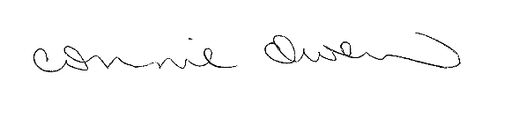
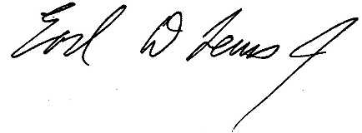
___________________________ ________________________
Connie Owen, Chair Earl Lewis, Secretary

